TASK 1:
PROMPT: generate a Python function that converts an amount from one currency to another using exchange rates stored in a dictionary and ask the user for input values and display it. Example1:100 usd converts to eur output:92.00eur
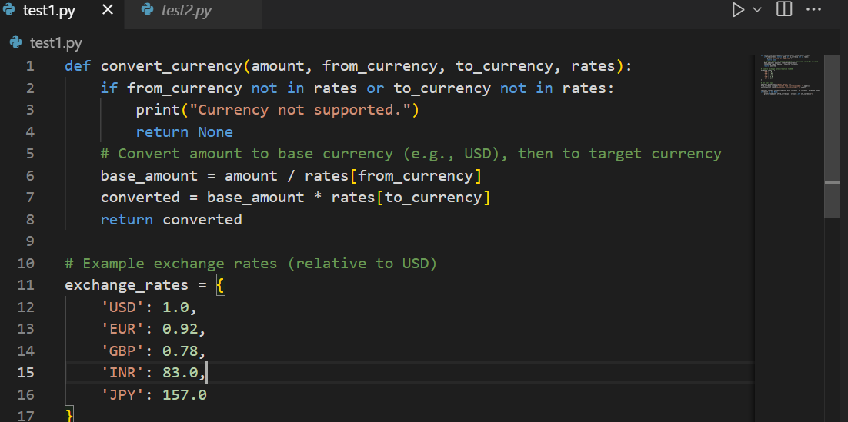
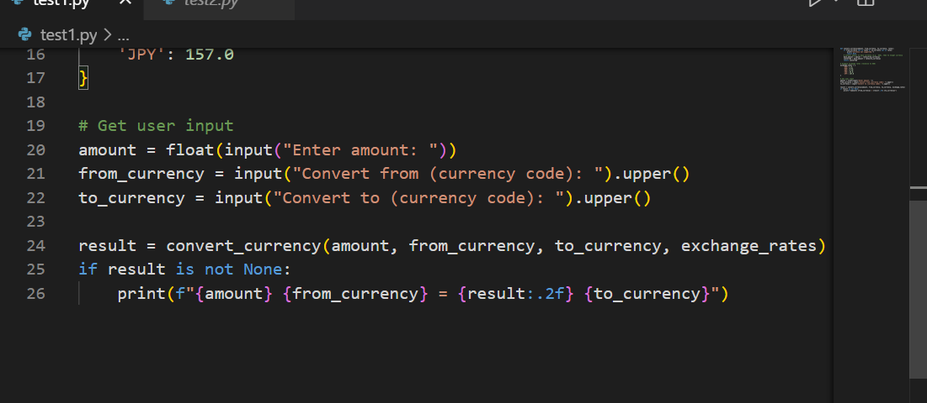
Output:
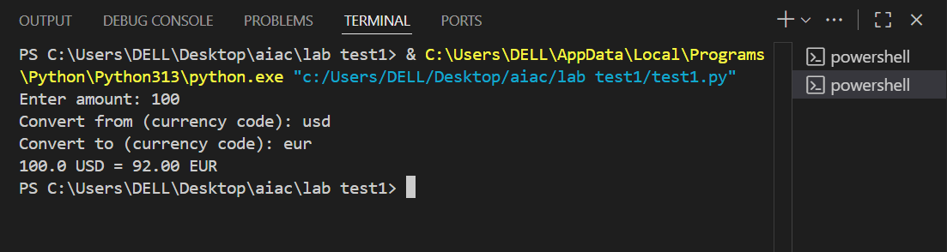
TASK 2:
PROMPT: generate a Python program to extract all email addresses from a block of text using regular
expressions
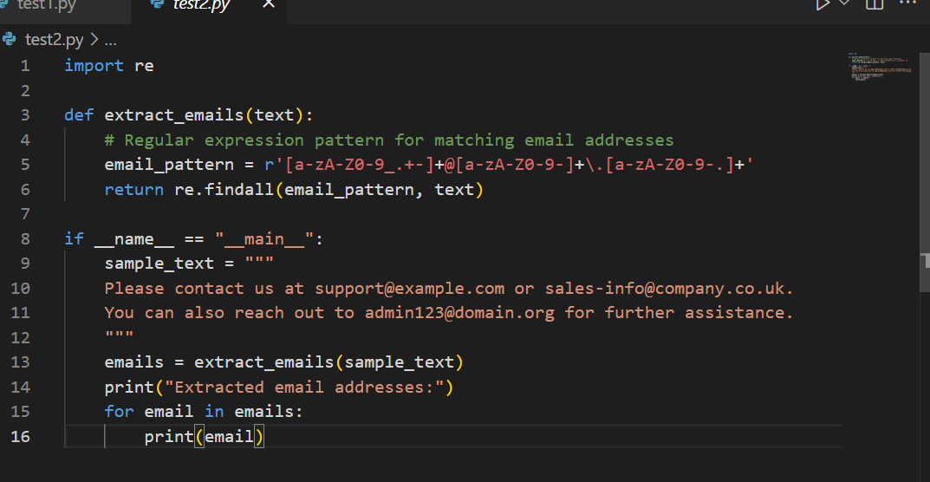
OUTPUT:
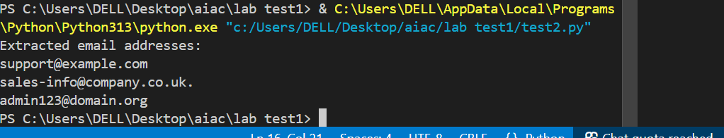
TASK 3:
PROMPT: generate a Python function that recommends movies based on a user’s preferred genreand and Given a list of movies with their genres and ask the input from the consol.Example1: Recommended movies in the genre”action” output: The Dark Knight 2. Recommended movies in the genre”drama” output: Forrest Gump
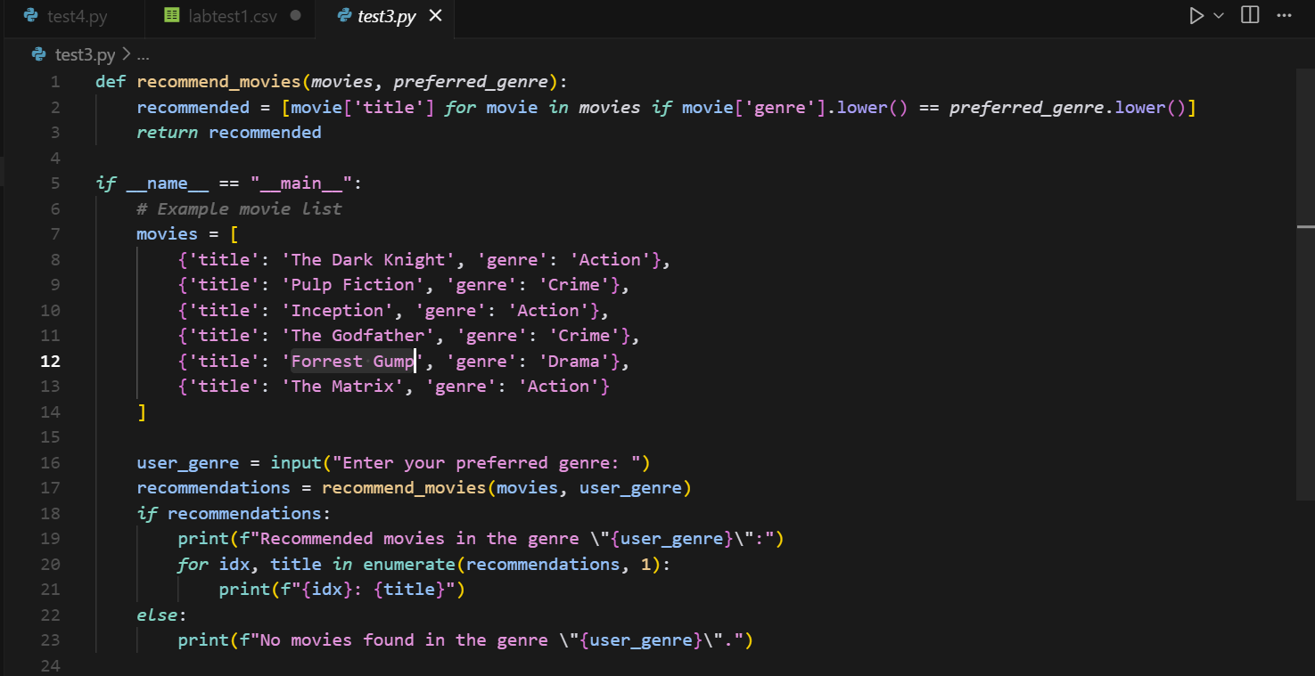
Output:
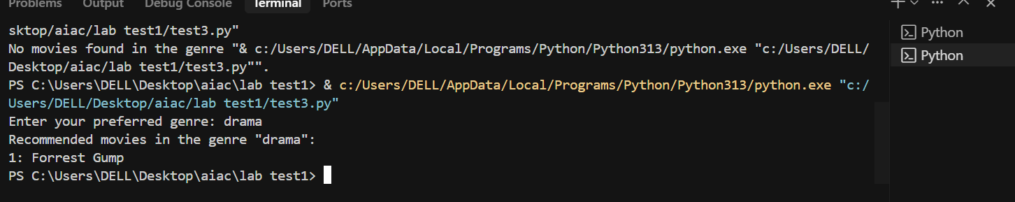
TASK 4:
PROMPT: Write Python code that reads a CSV file containing student names and marks in 3 subjects.Calculate the total and average marks for each student
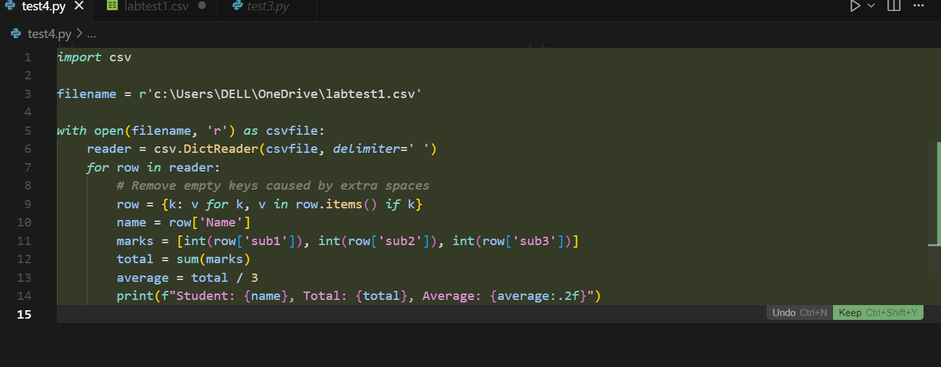
OUTPUT:

